Containerization and Orchestration Report Using Docker and Kubernete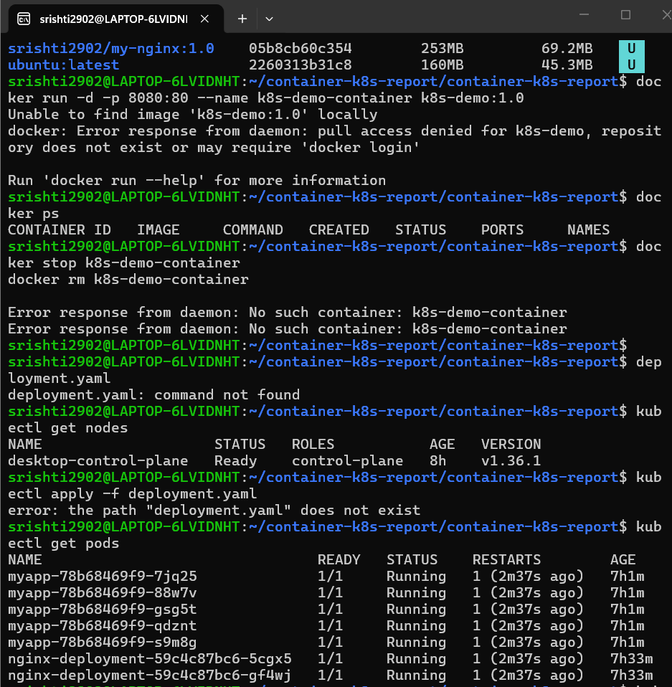 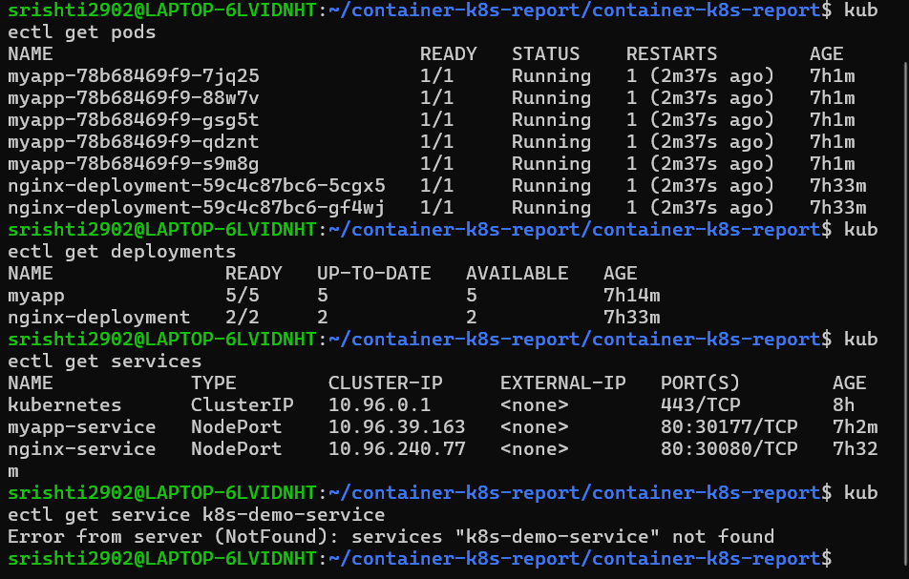
1. Objective

The objective of this practical is to containerize a web application using Docker and deploy it on a Kubernetes cluster. The practical demonstrates container creation, Kubernetes deployment, service exposure, scaling, and verification of the application.
2. Tools and Technologies
Tool | Purpose
Docker | Containerization
Kubernetes | Container orchestration
kubectl | Kubernetes cluster management
Nginx | Web server
HTML | Sample application
3. Architecture

Kubernetes Cluster

|

┌─────┴─────┐

| Deployment |

| myapp |

└─────┬─────┘

|

┌────────────┼────────────┐

↓ ↓ ↓

Pod 1 Pod 2 Pod 3

|

↓

Nginx Container

|

↓

Service

4. Containerization
Explain:
- Created index.html.
- Created Dockerfile.
- Built Docker image.
- Started a Docker container.
- Tested the application through the browser.
Insert Screenshots 1–5.
5. Kubernetes Deployment
Explain:
- Created deployment.yaml.
- Created service.yaml.
- Applied both manifests using kubectl.
- Verified Kubernetes nodes and pods.
- Accessed the application through the Kubernetes Service.
Insert Screenshots 6–11.
6. Scaling Strategy
Write:
The Kubernetes Deployment was initially configured with two replicas. The application was then scaled to four replicas using the kubectl scale command. Kubernetes automatically created additional pods to achieve the desired replica count. The application was subsequently scaled down to two replicas.
Add a small table:
Stage | Replicas | Result
Initial deployment | 2 | 2 pods running
Scale-up | 4 | 4 pods running
Scale-down | 2 | 2 pods running
Insert Screenshots 12–14.
7. Observations
You can write:
The Docker image successfully packaged the web application and its required web server environment. Kubernetes successfully deployed the application using a Deployment and exposed it through a Service. Multiple replicas of the application were maintained by Kubernetes. Scaling the Deployment increased or decreased the number of running pods according to the desired replica count. The application remained accessible through the Kubernetes Service during the deployment and scaling operations.
8. Result
The web application was successfully containerized using Docker and deployed on a Kubernetes cluster. The application was verified through running pods and a Kubernetes Service. Scaling operations were successfully performed from two replicas to four replicas and back to two replicas.
9. Conclusion
This practical demonstrated the complete containerization and orchestration workflow using Docker and Kubernetes. Docker was used to package the application into a container image, while Kubernetes was used to deploy, manage, expose, and scale the application. The experiment demonstrated the benefits of orchestration, including replica management, service exposure, and scalable application deployment.

